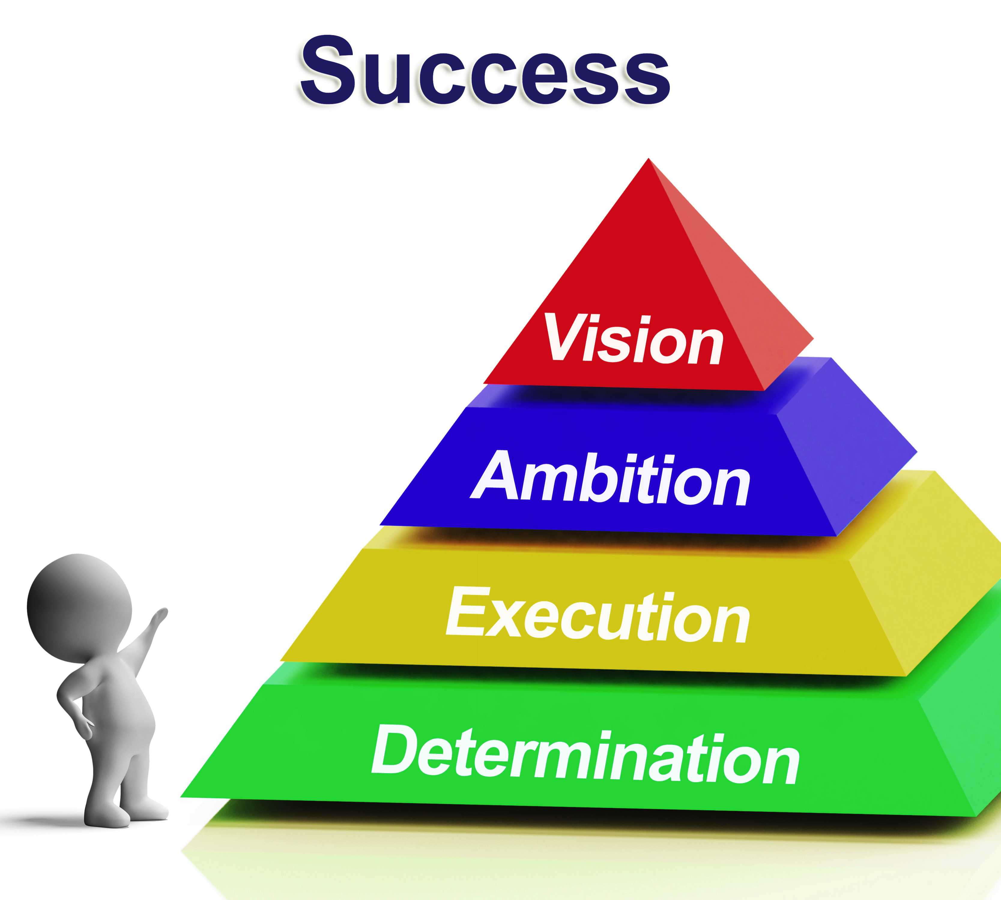

Table Of Contents

About Me……………………………………………………………………3

Dedication……………………………………………………………….. 6

Gratitude…………………………………………………………………..7

Introduction…………………………………………………………….. 8

Where Do We Start?............................................................... 9

The Pyramid……………………………………………………………11

The Magic Of Mindset……………………………………………...14

Rags To Riches………………………………………………………...16

The Science Behind Your Mindset …………………………. 29

Conclusion………………………………………………………………30

About Me

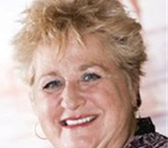

Hi I’m Barbara Williams.
I’m an
entrepreneur, author, and networker

I am pleased that you have an interest in my most passionate study, learning how to be better, think better and help others do the same.

Like you, I’m striving to become better, to live a grand life andIII leave a legacy of memories for my grandchildren. I write about how to set your sail, to enhance your mindset, as we can move from the struggle that we all face to become better people, parents, leaders, and contributors — and I am a health consultant.

I currently live just outside the San Francisco Bay Area with my lovely granddaughter Madison, our cat Anaya, and seven Miniature Schnauzers, my house is full. I love swimming in the summer in my pool. Madison makes me smile daily and warms my heart.

When I was first introduced to the power of positive thinking it was from my friend Ron English, who was a medical student at the University of California, San Francisco. At that time I was living on the corner of Parnassus and Shrader down the hill for UCSF. Ron gifted me with a book by Norman Vincent Peale, “The Power Of Positive Thinking”. This book stimulated my search for healing after years of battling depression and poverty.

Ron English, the good friend he was, also introduced me to several books. The next book I read was “Three Magic Words” by U.S. Anderson.

I remember clearly, as if it were yesterday, sitting on the couch listening to the San Francisco street cars go by while reading “Three Magic Words.” During the time that I was reading it was as if the author US Anderson were right there in the room with me talking to me personally. I began to feel hope well up inside of me as I continued to read.

My over three decade path of continued search and honing my skills in the law of attraction, positive thinking, mindset and more my life has continued to improve and my dreams proceed to be realized.

I give thanks for the
omnipotence of God.

Dedication

First and foremost I dedicate this book to my daughter/granddaughter Madison for without her this book would not be possible.

Further I dedicate this book to my steadfast friends, Johanna Baker and her husband Jim, Jennifer Nelson, Jeanne Meyer, Sue Mescher, Diane Alexander, Jocelyne Nielson,Dave Bradbury, Chris Sanchez, Cesar Garcia, Dr. Hines, Dr. Alan Kipperman and Dr. Ley-Han. Jeffery Combs assisted me greatly to become who I am today. Jerry Clark, Susan Sly, Ellie Drake and Artemis Limpert imparted deep meaningful lessons to my life.

Bob Proctor’s mindset lessons moved me greatly. T.Harv Eker provide me some excellent training.

I thank God for his omnipresence, omnipotence and commitment to my life, without him I shudder to think what that alternative would be.

Gratitude

I am thankful for my AA degree and 4 years of apprenticeship with the IBEW, International Brotherhood Of Electrical Workers Local 595.
I learned so much from the mindset of men and blue-collar workers. Many “salt of the earth” men graduate with their Bachelors Degrees in a variety of other subjects.

I am thankful for my dad who taught me hard work values and that women can do everything while he taught me how to fish, rebuild the foundation under the house and building.

I thank my mom who demonstrated excellent cooking. She always kept a clean and meticulously tidy house.

I thank for my friend ship with my high school friend Mark Rothenbuhler and his dad Glen and mom Bernice. They use to take me to the Catholic church on a regular basis.

I am thankful for my long term childhood friendship with Karen Vitalijic, who is now Mrs. Karen Evich.

On this “Rock” I do stand and world you will adjust.
Barbara Williams

Introduction

Success is elusive, a slippery slope and on the move.
Success is the progressive realization of a worthy ideal.
Success has numerous definitions.

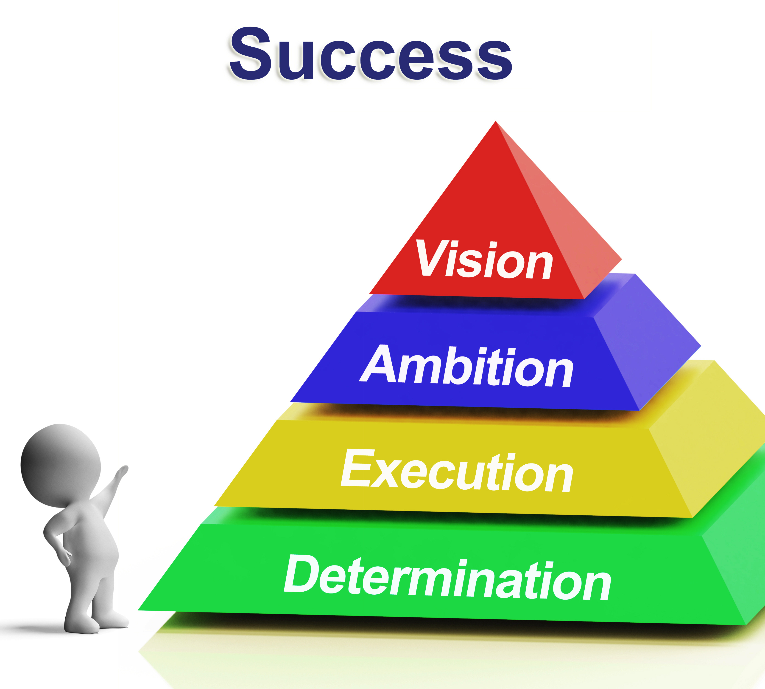

Where do we start?

When you are ready to move from more month than money to more money than month you are obliged to learn how to think. Change your mindset change your bottom line. When your attitude increases so do your profits. Be the change you want to see in the world.

Most people believe “How To’s” Rule, nay, nay I say it is……

Over and over again I am asked how to…? How to..? How to..? Like a “coo coo-clock”, how to? how to? how to? I will then answer the group their question and with all the proven success techniques on how to accomplish success in marketing yet they still fail…and I ask myself why …… knowing the answer….it is their improper mindset and visualization.

You currently may believe that you must learn “how to’s” do something and I am here to tell you that you must be compelled to change your mindset which trumps “how to’s” every day of the week.

I am not saying that you are not required to master a skillset however I am claiming that mindset will propel you to meet the right people and attract the right strategic skillset learning platform to skyrocket your pocketbook.

Mindset, the established set of attitudes held by someone, is everything. Without the correct mindset you are doomed to fail.

I know you have probably heard several times attraction marketing, law of attraction, attracting people, money, success and so it goes. However, it does start with possessing determination.

The Pyramid

Now burn the image of the pyramid, on the first page, in your mind. We will discuss the meaning of the rungs on the pyramid.

Imagine from the top of the pyramid, where the success flag is on the image of the cover of this book, there is hanging a pendulum. The apex of the pyramid is representative of perfect balance in your life. With this balance you will possess focus to be able to fine-tune your vision.

Now at the bottom of the pyramid the pendulum is a ball that says “start here”. At the level of determination the pendulum swings wide from side to side, however at the pinnacle of the pyramid where is located the vision and success. Here the pendulum does not swing, or swings ever so slightly.

According to Jeffery Combs, the President of Golden Mastermind Seminars Inc., at http://GoldenMastermind.com , you always must strive to make you “highs” low and your “lows” high so you are always flat lining your emotions and your responses as you produce and create your desired lifestyle. In this zone similar to our apex and pendulum theory you will and always will be able to produce at your highest potential.

Again hold the image of the book cover in your mind.

Even though determination is at the bottom rung of the pyramid without it nothing moves.

Attitude determines your altitude. With the best mindset and the set of successful attitudes you are able to take DETERMINATION, the controlling or deciding of something's outcome, to EXECUTION, the carrying out or putting into effect a plan, order, or course of action and you’re on the road to AMBITION, a strong desire to do or to achieve something, typically requiring determination and hard work.

However, our ultimate goal is to live in the zone of VISION, the ability to think about or plan the future with imagination or wisdom; a mental image of what the future will or could be like, for example a vision of retirement. Then this vision of retirement will lead to the reality of that which he envisioned. In the zone of VISION you are successful and your dreams, visions, and imagination are fulfilled, enjoyed and shared in your newly created lifestyle of success.

You will definitely fail to achieve your goals and purpose if you do not master the law of attraction, which happens as a result of mindset and vision.

Our aim is to reach the pinnacle of possibilities at the summit of the pyramid.
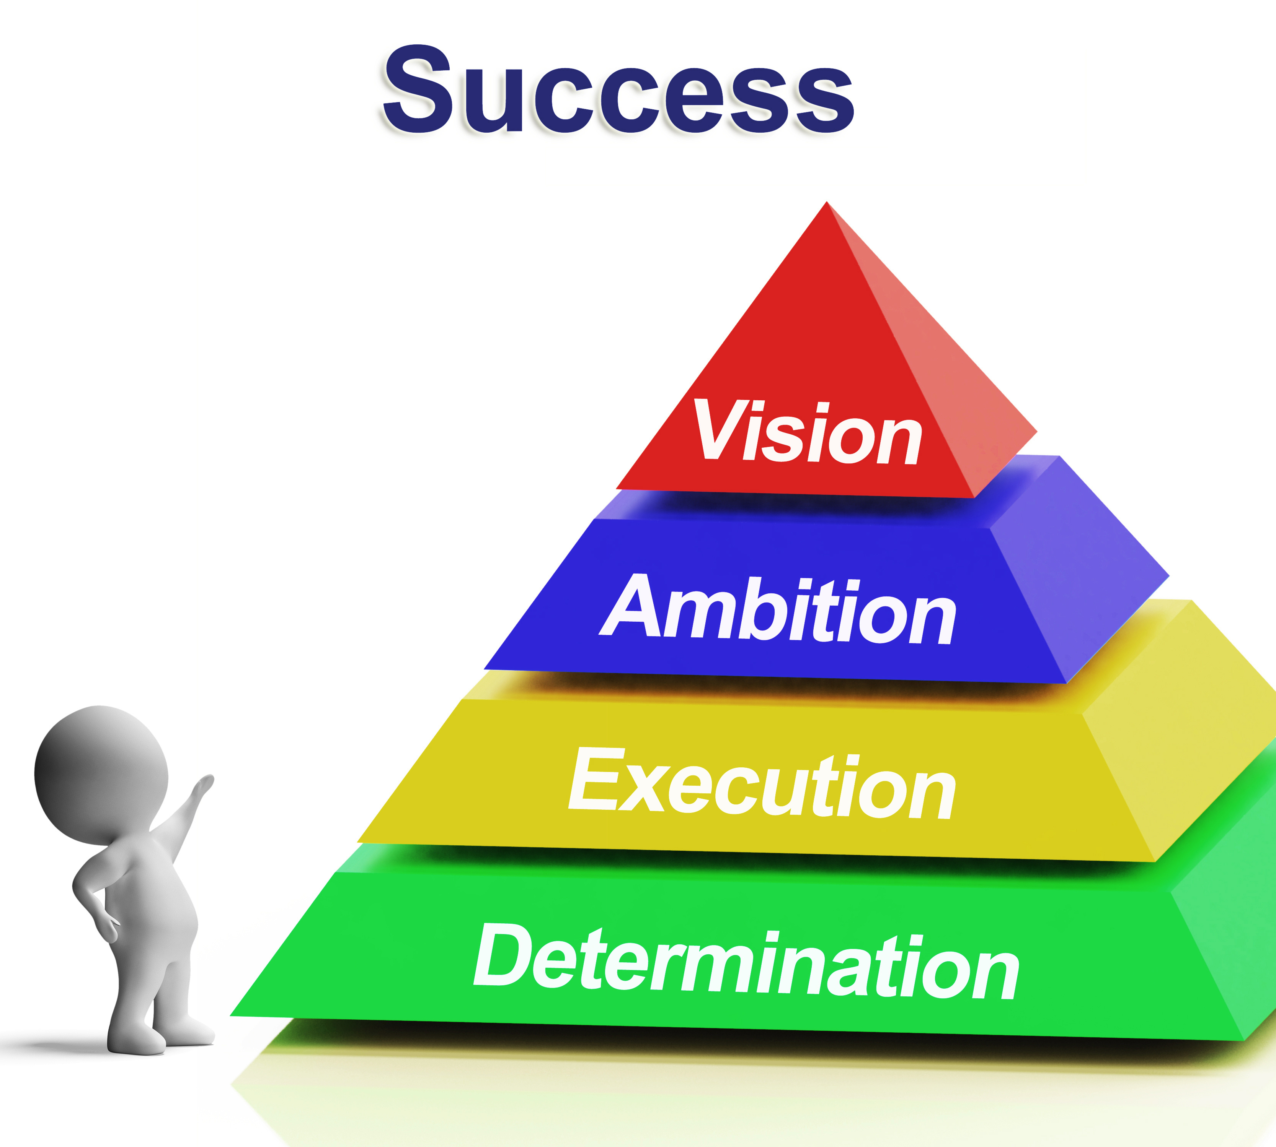

DETERMINATION»»»EXECUTION»»AMBITION»»VISION»»
SUCCESS

Another method of looking at this pyramid is:

Decision - (in place of Determination)
Action - Execution
Passion - Ambition
Imagination visualization – now you’re in the red - VISION
RESULTS - SUCCESS – Triumph – The Pay Off – Affluence -
Hollywood Ending – Prosperity – Wealth – Riches – Opulence

By whatever the name you are a WINNER!

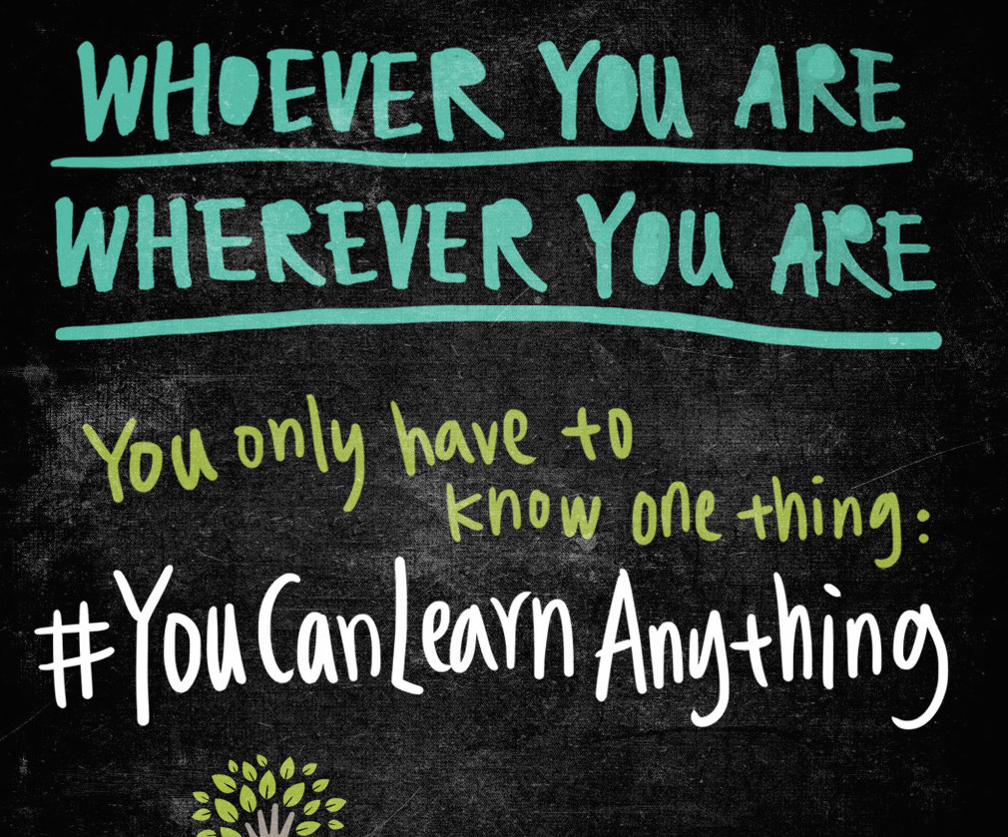

The Magic Of Mindset

When you realize the importance of a positive and decisive mindset and how it can enhance your future you will also discover that you can learn how to become more positive, with a better attitude and you too will be showered with the benefits.

We were born to be rich. We were born to learn.
We were born to dream!!!
These are our birthrights!

When you can see and envision your desired lifestyle and hold the image in mind over time with belief that you can, you will and you deserve to create your desired lifestyle; it appears like magic.

We all can learn anything we have a passion to learn. We can learn everything we choose and decide to learn.

Dreaming, believing, conviction, determination, execution, ambition, passion, action, vision are several of the key ingredients that design success and triumph. You can learn all of these positive attitudes and more.

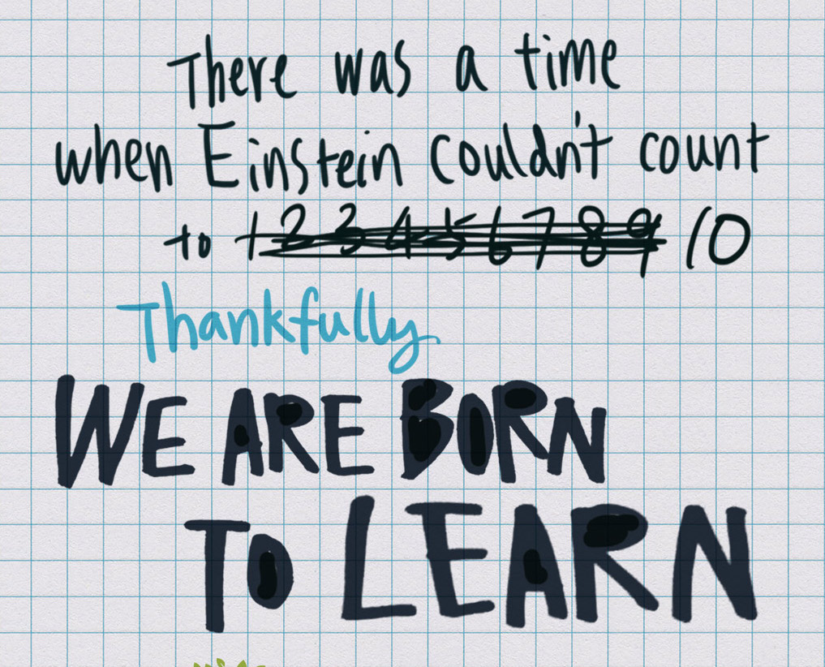

Leaders are readers and readers are leaders. We were born to learn.

Those that choose NOT to move forward on their birthright are cheating themselves of all that happiness in the world.

Rags To Riches



Rags to riches

Most of us have heard of the rags to riches stories. Correct? Let’s just say for sake of argument that poverty signifies the rags which is the metaphor for poor thinking. Poor thinking is a poverty consciousness that is multi-generational. This leads to an ever-revolving negative set of circumstances.

Riches in the “Rags To Riches” story represent the rich, opulent, big and out of the box ideas that wealthy people have inherited. When we refer to ….”he was born with a silver spoon in his mouth” is truly just that. He inherited the proper, creative, positive, and large thinking that creates outrageous wealth. Consequently positive and creative ideas manifest money on the physical plain of reality and this is a fact! So rich people’s money is a multi-generational advantage through proper and positive thinking.

I have a friend by the name of Wanda who was eating on food stamps, raising two children on welfare, living in a modest home and no money to raise her children alone. She joined a network marketing company and in less than a year was driving a jag.

This could be you.

Wanda was not lucky nor lived this new lifestyle because she worked harder or was smarter than everyone else. No, Wanda had determination, execution, ambition and vision. Therefore, her vision led her to dream and to create her new lifestyle.

Many other people joined this same company and were not celebrating outrageous success like Wanda.

What made Wanda different than all the thousands of other distributors?

She a developed her mindset to win and she held in mind over time the picture of her jaguar. She learned to develop her imagination, dreaming and vision abilities.

So why is this?

Wanda combined right thinking, the correct mindset and attitude with the right company, and taking the right action.

Thought plus belief plus action equals outlandish results.
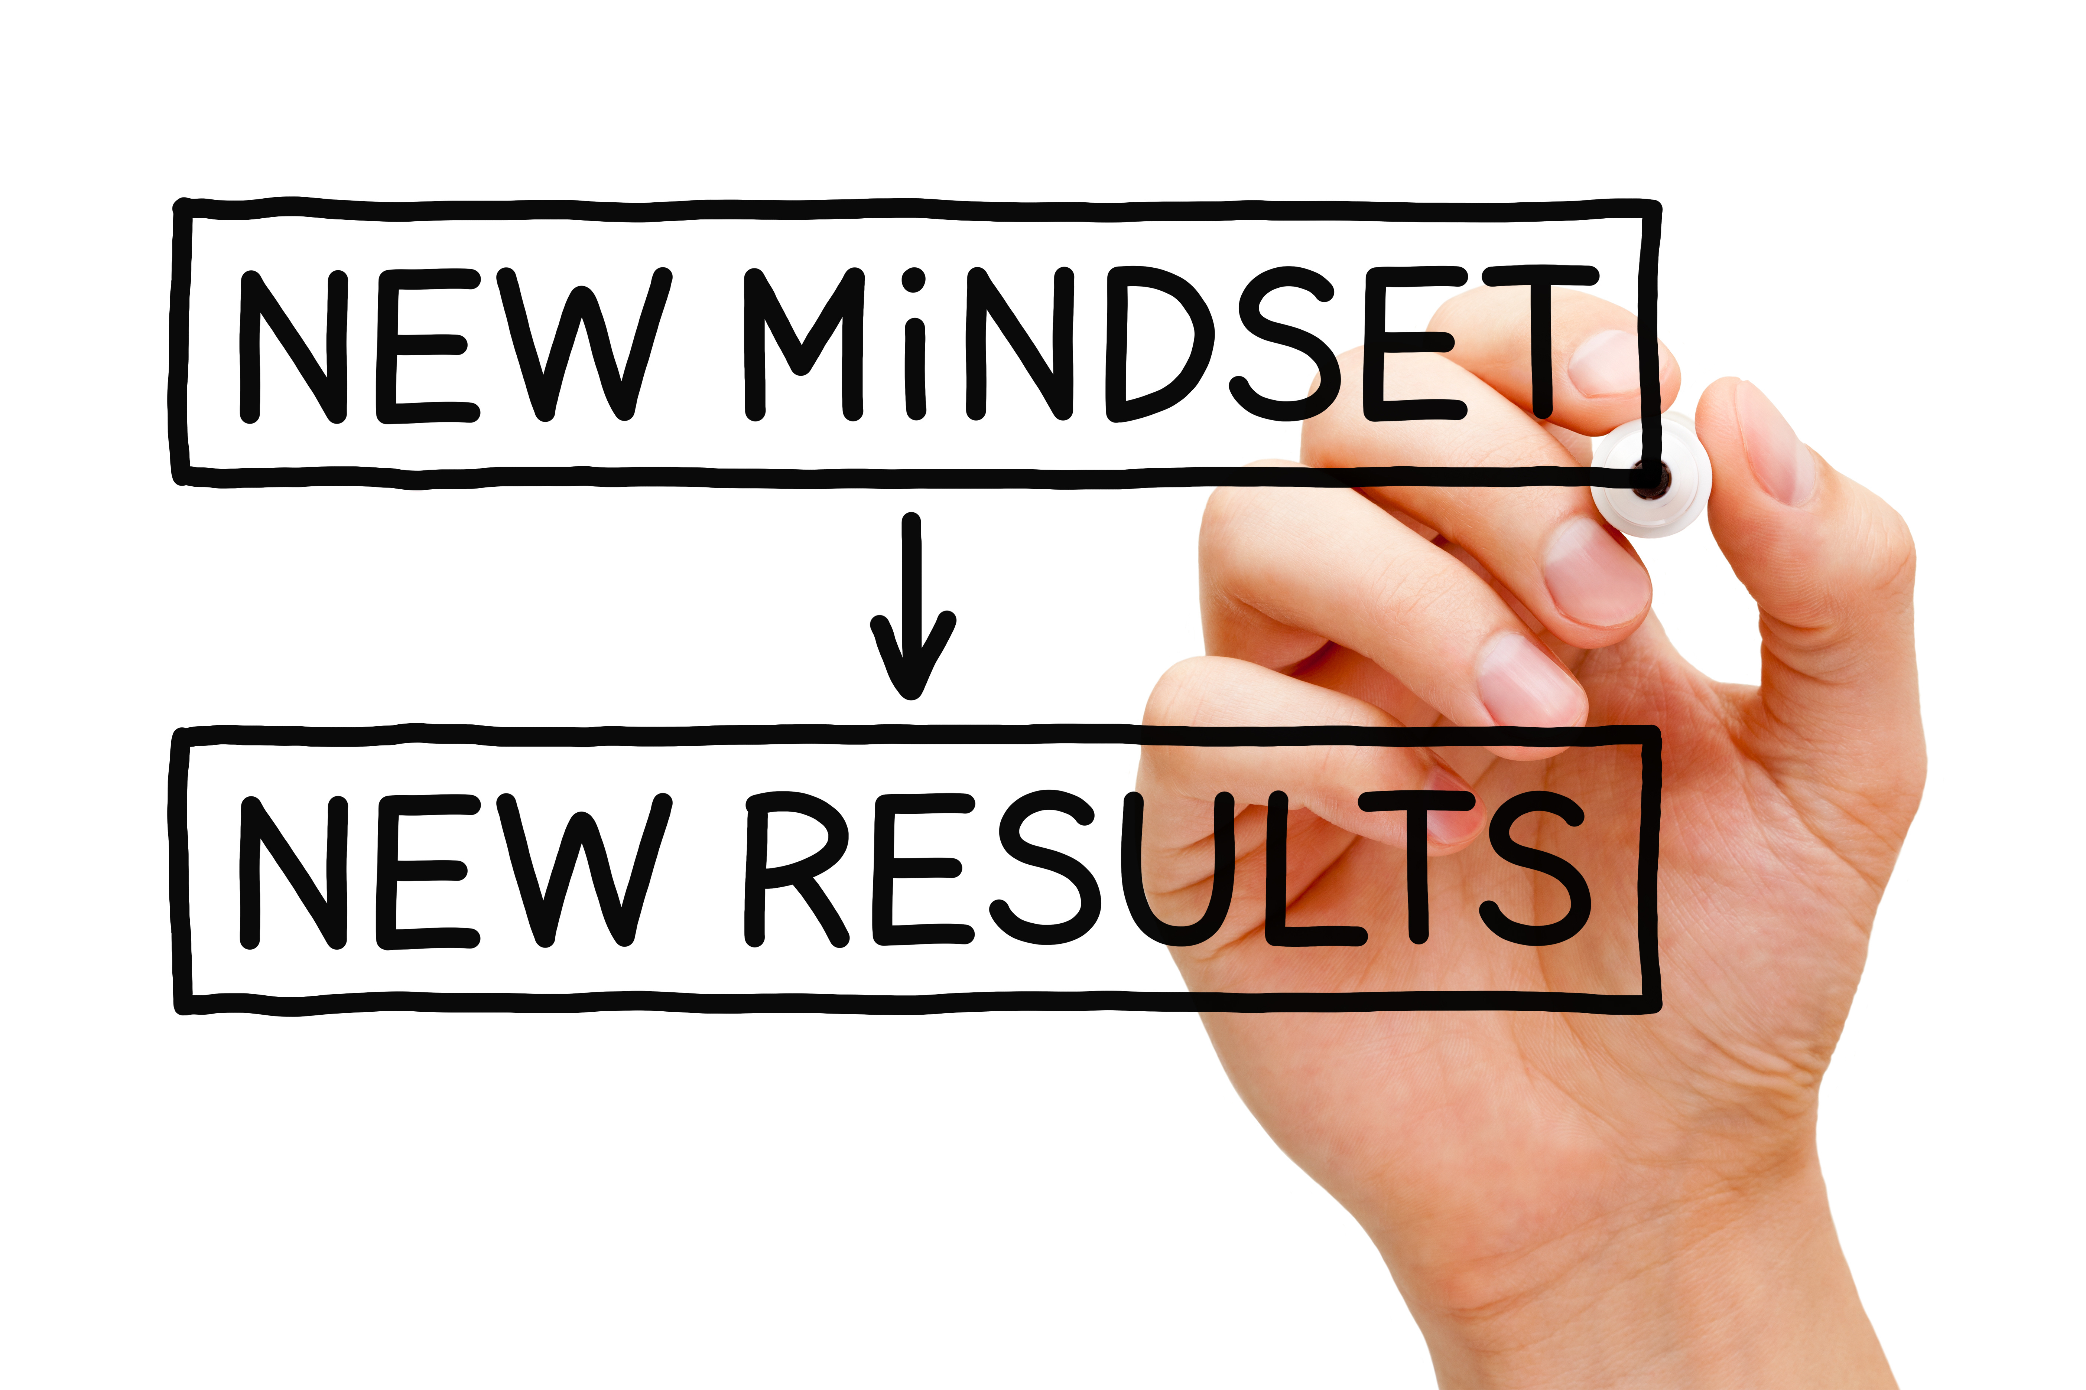

There are many rags to riches stories yet most people do not celebrate these same results because of their improper mindset. That is why only 5% of the population are truly wealthy. Look at the U.S. Census.

I was with the same company as Wanda and I watched many other families fail and many families succeed. Her correct thinking combined with belief plus action was more important than the company she chose.

The only difference was positive thinking, creative thinking combined with action.

Story……

I started my quest of power of positive thinking, meditation, believing, and thirst to be more, do more and have more also began. I embarked on daily reading, and listening to information on this subject. Everyday almost 24 hours a day I listened to empowering intelligence, and various speakers.

My brain is full of Jerry Clark, Jeffery Combs, Brian Tracy, Anthony Robbins, T Harv Eker, Jim Rohn, Zig Ziglar, Artemis Limpert, Ellie Drake, Susan Sly, Bob Proctor, Claude Bristol, James Allen, Ken Keyes, U.S. Anderson, Lazaris, and the list goes on and on.

Years ago, just after my newfound quest for enlightenment, I decided I would be a Union Electrician. I also decided I would be accepted into the Union Electrician Apprenticeship Program.

I envisioned what I wanted and I believed it would come to pass. I combined my image held in my mind with action. I began to attend classes at a women’s apprenticeship tutorial program in San Francisco.

I applied, tested and interviewed for three union locals in the bay area.

To give you a little background. The electrical union apprenticeship programs only accept applications once every two years, for a two week period of time for only two hours a day Monday through Friday.

The qualifications to apply were high school diploma with 1 year of algebra with a “C” or better. Thankfully I fulfilled minimum qualifications.

Taking baby steps, poco a poco, I put one foot in front of the other.

Then the day to apply arrived.

Then a few weeks later the day to do written and manual testing materialized.

Well, “por fin”, finally, then day came, a few months later, for me to show-up and suit-up for my interview. Of course, this is only because I had passed the other tests.

I waited in the bathroom ……. I mediated……. “I will say everything they want to hear”….. “they will like me”…..”the will choose me” …..
Everything will be in flow motion….. “they will pick me”……. “I will answer all there questions perfectly”…… “ It will flow perfectly”!!!
Over and Over again I visualized my dedications and affirmations.

Then, the moment came and I was called into the room. I entered the interview room and to my surprise appeared the longest table I have every seen in history. I was escorted to one end of the table and a man sat at the other end. Then, if this were not enough, on each side of the table were seated six men on each side. I have to say the staging was a little intimidating in and of itself.

I sat down, threw my shoulders back, held my head high and straightened my back while all the while the affirmations were still playing in my mind. I was ready.

Around and around the table the men began to randomly question me. Just like my bathroom affirmations all the answers flowed from my mouth beautifully. I was a brilliant silver tongued beauty guided by someone other than me.

The answers slid off my tongue like silk and then we were finished.

I proudly walked out the door, inwardly smiling, because I knew the interview was perfect and I was awe-inspiring.

Three months later, one day after I delivered my child Rachael, the letter came in the mail, I was accepted into the Union Electrical Local 595, Alameda County Program. I was stupefied!!!

I gave thanks!!! Repeatedly I gave thanks.

There were 1700 applicants, 300 women applicants and only 11 women were chosen out of three hundred women.

In my class, which was the last class that was voted in to teach apprentices, were 1 woman who was a marine electrician journeyman and the other woman was an electronics graduate.

Here I was a high school graduate.

The entire process took over 1 year to be accepted and to start evening classes.

It took over 2 years before the work portion of the apprenticeship started.

The entire 4 year apprenticeship program became a class program of 5 years.

Then the day came for the “rite of passage” the electrical test, in order to test out as a journeyman electrician.

There I was proudly standing amongst these extremely qualified individuals and I myself was a high school graduate.

Story…..

Now this next story is a representation of negative thinking and not possessing the proper mindset. I know a woman by the name of Jasmine, she and I were in the same company. It always perplexed me, that everyone that she introduced our product to; they did not like the taste.

No one ever ordered her product. However, everyone liked the taste of my product, which was the same drink, they all joined and 19 years later they are still drinking the same product. So what was the difference between Jasmine and me. Jasmine believed it was too expensive so everyone she met believed it was too expensive. She believed that the taste was not that good even though she was receiving excellent results. Everyone she let taste her delectable product hated it.

So we had the same product from the same company however, we had incredibly different results. So why is this? We had different thinking and beliefs.

Story……



Our next story takes place in San Francisco on a sunny Saturday afternoon in the downtown district.

One beautiful sunny day, my husband and I jumped into our green Honda Civic 4-door sedan and off we flew from Livermore. We took my daughter Rachael to her voice and acting lessons at ACT, American Conservatory Theatre, in San Francisco.

Here is a little geography, San Francisco is almost 2 hours from my home in Livermore. Our drive was rather smooth with great traffic. After arriving at Rachael’s destination there was not any parking. So we circled the block a couple of times and still nothing, so we pulled up to the curb, then Rachael disembarked from our green Civic.

It was a breath-taking day in San Francisco. The air was fresh with a scent of sea water and the sky was clear and majestic. What an awe-inspiring day so, I suddenly turned to my husband and said, “Honey you have always talked about owning a Mercedes, let’s go see how much they cost. We can pick up some images for our dreamboard, and we’ll then have a number to work with. Okay?”

So he said, “yes”, and then off we went to the Mercedes dealership on Van Ness avenue to view their showroom floor.

We so enjoyed looking at all the makes, models, years and colors. It truly was an exciting day of dreaming.

Then all of a sudden we looked at our watch to discover it was time to pick Rachael up so off we flew!!!

When we reach ACT Rachael was waiting in front, her mouth dropped and her eyes lit up with excitement as she jumped into the new beige Mercedes Benz!!!

Yes, we turned an idea, a thought, a dream into reality and you can too.

Jeffery Combs always says, “you deserve to have it all!”

NEXT Day…..

I sat down to watch my daily DVD “The Winner’s Image”, a program produced by Bob Proctor. With my eyes glued to the TV watching Bob’s motivational DVD, suddenly flashing before my eyes was my beige Mercedes Benz, same year make and model. I jumped and leaped through the roof with shock, surprise and total amazement, then I ran through the house screaming “Prem omg my car is on TV”.

That Bob Proctor image had been flashing before my eyes for a couple of weeks and the next thing I was driving was the same image I had been viewing. I manifest what was planted in my subconscious mind.

Story….

One of my mentors once told me to write on a 3x5 card , in one or two words that which I wanted in my life. So, I did it.

I wrote Spanish, French, Mercedes, piano, home, and husband.

None of these goals manifested quickly, however, all of them did come to pass.

For example, for the life of me, I cannot remember why, I wrote Spanish and French, however, I will tell you the result. I am now a Spanish Literature graduate with a French minor.

Shortly after writing the word piano I moved a piano into my single- wide mobile home and my daughter started her piano lessons.

Then I bought my first starter home even though I had bad credit and no money saved.
Then several years later after view Bob Proctor DVD the Merced Benz became a part of my life.

Story…..



He is another story of imaging and mindset. It came to pass that I did not like the ride of a Mercedes. Actually, even though I have owned a Mercedes and three BMWs my favorite car is a Honda Accord.

One day I decided I wanted to own a white Honda Accord, so I went to the Honda dealership and I took home the pamphlet for the Hondas and I put a picture on the wall in my kitchen.

The kitchen is the center of the house and I walk through the kitchen several times a day. Each time when I walked through the kitchen I viewed the picture of the Honda; I intended to buy a white Honda.

Thought and intent plus belief equal manifestation onto the physical plain of reality.

A year passed, I walked into the kitchen then turned to my husband, “today is the day, today, is the day we are meant to buy my white Honda, let’s go!” I did not save the money or do anything special except view the photo. I simply knew in a magical way that today was the day!

So we jumped in the car and off we drove to Berkeley Honda with the intent to buy my new white Honda.

We arrived in Berkeley.

Again, with enthusiasm, intent and belief, I knew I was to drive home the newest model of Honda.

I looked at the new model of the white Honda Accord, however, repeatedly my vision was drawn to the beige Honda.

I said to myself, “this is weird, why do I keep looking at the beige Honda when I know I hate beige and I love white?” Weird it was!!!

The next thing I remember is driving home to Livermore, in the San Francisco Bay Area, in my new Honda Accord, beige. Weird.

When I arrived home I immediately walked into the kitchen and there in front of me was the image of my Honda Accord, beige. Weird.

When we hold an image in mind over time it will manifest itself in reality!


Story….

The other day while writing this ebook. I sudden attracted $1,800.!!

I guess it is due to thinking all of these positive and attractive thoughts!

Yet another example of mindset, attitude and action!

The Science Behind Your Mindset

The science of mindset states that your subconscious mind began to develop both positive and negative thoughts from birth. We come out of the womb, then slapped on the buttocks starts the infant to cry.

We start by controlling our thoughts through learning that we have the power to choose who we surround ourselves with and the thoughts we choose to entertain.

Controlling and believing in the positive thoughts we hold in mind over time is paramount. Because the most dominate thought held in mind over time will always manifest itself on the physical plain of reality.

We start with our thinking making it positive, creative and out of the box. Then we take an idea and develop it through our imagination, visualization, and almost a magical thinking process. A part of this is creating a new mindset.

Those people that started their journey to attain success from the “wrong side of the tracks” are through knowledge able to shift and change their mindset to overcome the multi-generational negative thinking that put him and his family in poverty in the first place.

Know this “thought plus Conviction equals a positive outcome for the thought you held in mind over time. Or in other words thought plus conviction equals manifestation.

Hold this in your mind, the “Golden Gate Bridge” would not and could not have been built if it were not FIRST a thought, an idea, and an image held in a man’s mind over time that then lead to the realize of what we now see, “The Golden Gate Bridge”.

Conclusion

All successful people became successful as a result of mindset. However, not everyone knows how to use it successfully.

Everyone uses “mindset” either to create good or evil.

Remember, what you hold in your mind over time will be actualized. The most dominant thought in you mind with belief will be realized.

One of an infinite number of examples is the “Golden Gate Bridge”.
I often ask which came first the bridge or the idea. A puzzled look comes over their face and as they think about the question they will sometimes answer the bridge and other times the idea. However, you and I both know it was the “IDEA”! It is always the idea first before anything whether it is to buy a car, create a vacation to the Bahamas or decision your money goals, it is always preceded by the idea and faith.

Consequently, now knowing the methodology of this tool we are positioned to create the life we choose.

Your future is one thought away.

Once you have your “Mindstuff” in order now it is time to learn the “How To’s”!!!



Live Your Life Without Limits….

The World Is Yours!
To Be Rich Is Not Everything However, It Rates Right Up There With Oxygen!

We all must have air to breathe as well as we require money for food, shelter, well-being,
helping our children and family,
yep…right up there with oxygen!!!!


I thank God For His Guidance In Writing This ebook.

Author

The Barbara Williams

http://BarbaraWilliams.net

